

Name: ________________________________

Human Biology ATAR

Task 10 Validation – DNA

Weight 10%

1. a) Explain what is meant by gene expression. (2 marks)  
   _______________________________________________________________________________________________________________________________________________________________________________________________________________________________________________________________________________________________________________________________________________

b) How does gene expression relate to a cell in a salivary gland? (2 marks)  
_______________________________________________________________________________________________________________________________________________________________________________________________________________________________________________________________________________________________________________________________________________

1. Explain how the epigenome allows the first section of DNA to be transcribed but not the second. (4 marks)

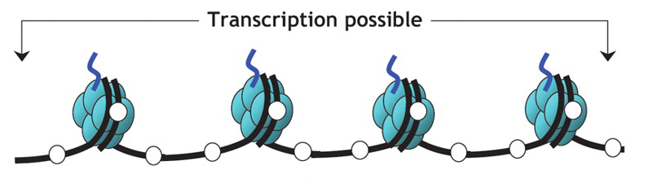

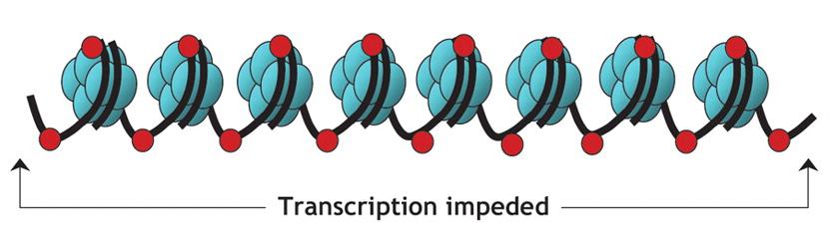  
_________________________________________________________________________________________________________________________________________________________________________________________________________

______________________________________________________________________________________________________________________________________

_______________________________________________________________________________________________________________________________________________________________________________________________________________________________________________________________________________________________________________________________________________

1. Seventeen-year-old identical twins, Adam and Michael, are both considered to be tall individuals: Adam is 192 cm and Michael is 188 cm. Explain how the different heights of Adam and Michael can be attributed to epigenetics. (3 marks)  
     
   _______________________________________________________________________________________________________________________________________________________________________________________________________________________________________________________________________________________________________________________________________________
2. Using an example explain how the discovery of epigenetic factors has transformed the way we think about characteristics that can be passed from one generation to another. (4 marks)

_______________________________________________________________________________________________________________________________________________________________________________________________________________________________________________________________________________________________________________________________________________

_______________________________________________________________________________________________________________________________________________________________________________________________________________________________________________________________________________________________________________________________________________